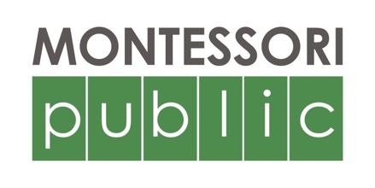

Montessori Public Print Edition
Advertising Contract

Advertiser's Business:

Contact Name:

Billing Address:

Email: Phone:

Indicate size and color or black and white below:

size | color | black and white
Full page  10^{3/8} x 12^{5/8} " | $2000 | $1500
Half page  5 x 12^{5/8}" (v)  10 ^{3/8} x 6 ^{1/8} " (hz) | $1500 | $1000
Quarter page  5 x 6^{1/8}" | $1000 | $700
Eighth  2^{3/8} x 6^{1/8} " (v)  5 x 3" (hz) | $500 | $400
Sixteenth  2 ^{3/8} x 3" | $300 | $200

Deadlines:
- Advertising contracts are due by March 8, 2017. Contracts received after that date will be accepted on a space-available basis.
- Payment is due with advertising contracts.
- Advertising copy — print-ready, 200dpi PDFs — due on March 15, 2017.

Payment information:
Payment Type: Check Credit Card
Credit Card Number:
Expiration Date: Billing Zipcode: CVC code:

